Seattle-ops-301d10: Lab 09

Zachariah Woodbridge Dec 7, 2023

# 

# **Lab: Traffic Mirroring**

## **Overview**

**Configuring the network for optimal visibility by security tools is essential in the modern era. One method involves duplicating or “mirroring” network traffic to a sniffing tool. This allows the tool to monitor all traffic passing through the mirrored interface.**

## **Scenario**

**After the network intrusion incident, the GlobeX MSP, Secutronix, performed and in-depth review of GlobeX’s primary LAN subnet and determined additional security measures would be necessary to detect such a threat in the future. Secutronix is about to deploy a new IDS (Intrusion Detection System) on the GlobeX network, but they’re requesting that a “span port” be created that will mirror all traffic on the primary subnet interface.**

## **Prerequisites**

* **A pfSense VM in VirtualBox, free from configuration settings from previous labs**
* **A Kali VM in VirtualBox**
* **A user endpoint VM in VirtualBox (any existing Windows 10 or Linux VM)**

## **Objectives**

* **Create a span port on pfSense that mirrors the traffic from the LAN network interface**
* **Configure Kali Linux so that it can capture traffic on a dedicated sniffing port**
* **Live-capture LAN traffic using Wireshark on Kali Linux**

## **Resources**

* [**pfSense Docs - Interface Bridges**](https://docs.netgate.com/pfsense/en/latest/bridges/index.html)

## **Tasks**

### **Part 1: Topology 1/2**

**Read through the entire lab and use Draw.io to create an appropriate topology of the network you expect to construct. Include as many details as you can such as computer names, OS types, IP addresses, etc. Include a screenshot of this initial topology.**

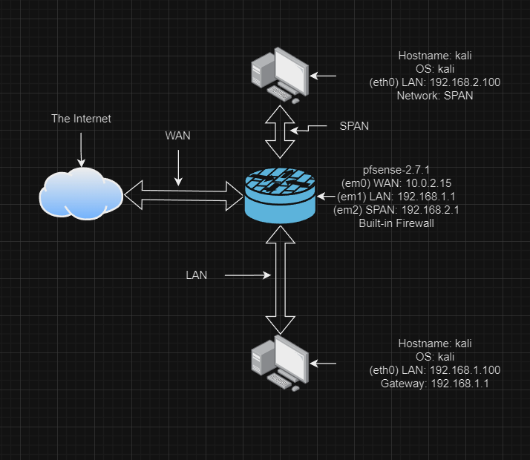

### **Part 2: Staging**

**Submit detailed documentation regarding all of the configurations in this section.**

* **~~First you will need a fresh pfSense VM, free from configuration settings from previous labs. You can reset an existing instance to factory settings (Diagnostics / Factory Defaults), revert to a baseline snapshot, import a fresh instance from a baseline OVA backup, or install pfSense on a new VM. However you achieve this, it is important to start from a clean baseline to avoid complications.~~**
  + **~~On the pfSense VM, configure the WAN network adapter to NAT Network and the LAN adapter to Internal Network.~~**

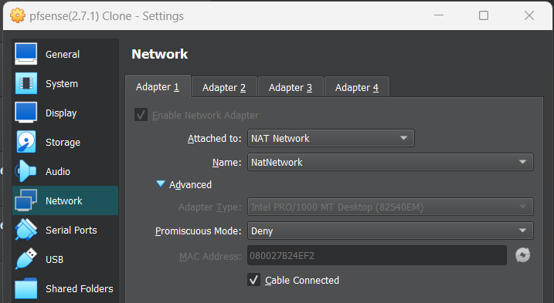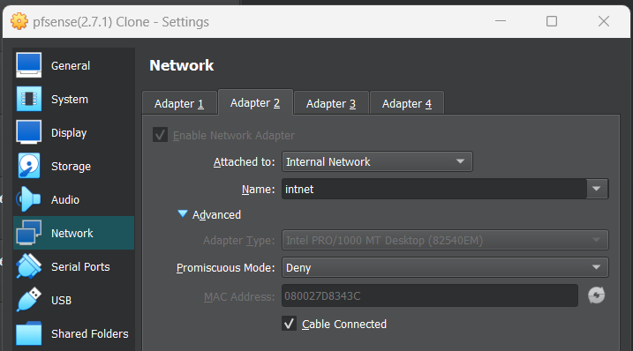

* + **~~Then enable a third network adapter and attach it to Internal Network. Create a new internal network named Span for this adapter.~~**
    - **~~Set Promiscuous Mode to Allow All on this Span adapter.~~**

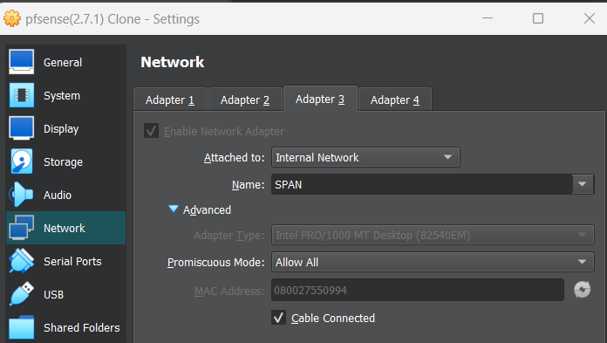

* **~~On your Kali VM, configure the network adapter to Internal Network and connect it to the same Span network as the new adapter on pfSense.~~**
  + **~~Set Promiscuous Mode to Allow All on this adapter.~~**

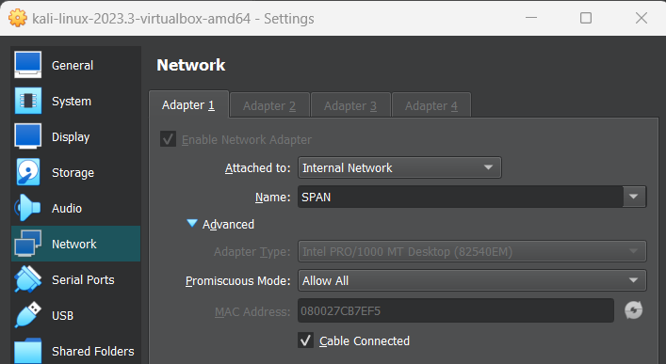

* **~~On the user endpoint VM, configure the network adapter to match the LAN adapter of pfSense (should be set to the same Internal Network). We will need this machine to generate traffic for us to capture.~~**

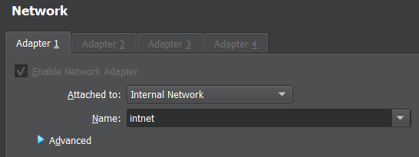

### **Part 3: Prepare a Span Port on pfSense**

**We want pfSense to mirror all LAN traffic to this connection**

* **~~In Interfaces / Assignments / Interface Assignments, add a new interface associated with the new network adapter~~**
* **~~Configure the new interface~~**
  + **~~Enable the interface~~**
  + **~~Give the interface an appropriate name (default is likely OPT1)~~**

**I know there is an OPT2, but it is unused.**

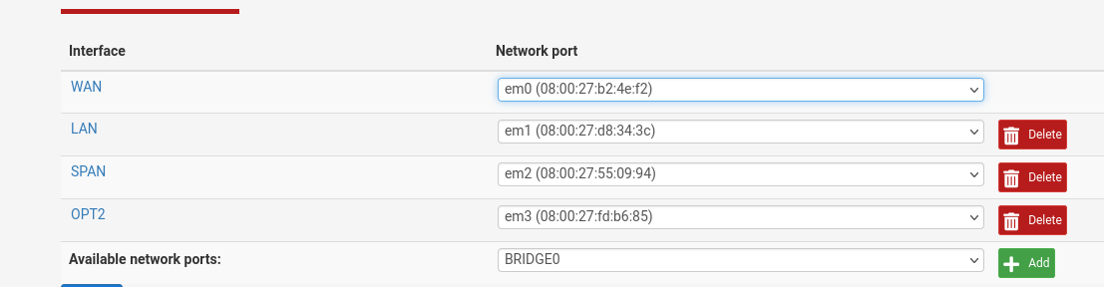

* **~~In Interfaces / Assignments / Bridges, add a bridge with the following configuration:~~**
  + **~~Member Interfaces: LAN~~**
  + **~~Span Port: whatever interface you just created~~**

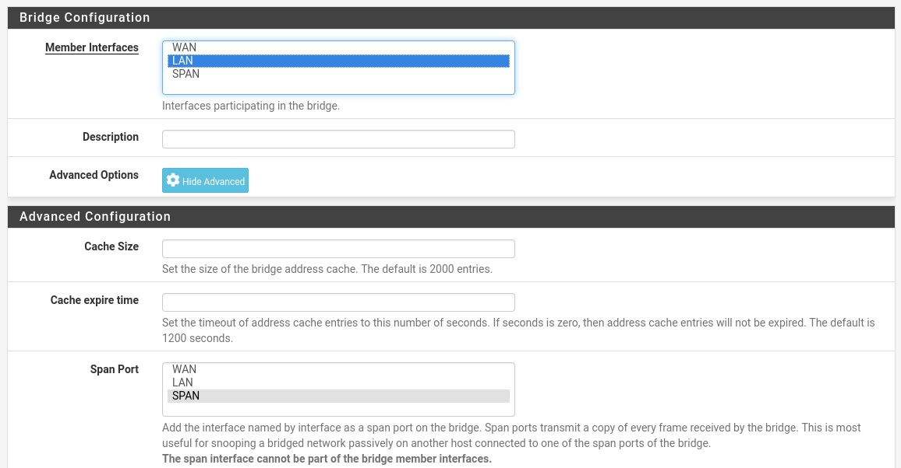

### **Part 4: Capture Packets with Kali**

**Now we will use Wireshark on Kali to sniff for network traffic on the span connection.**

* **~~Make sure another VM is connected on the LAN, and use it to ping scanme.nmap.org~~*~~Hint: you can make Windows 10 ping continuously by adding a -t flag, as in ping scanme.nmap.org -t~~***

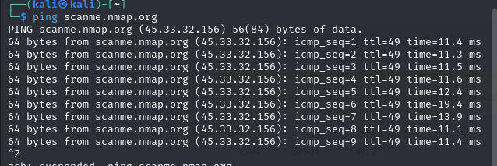

* **~~On Kali, set Wireshark to capture traffic on the interface associated with the span connection we set up earlier~~**
* **~~Include a screenshot of pings out to scanme.nmap.org captured in Wireshark~~**

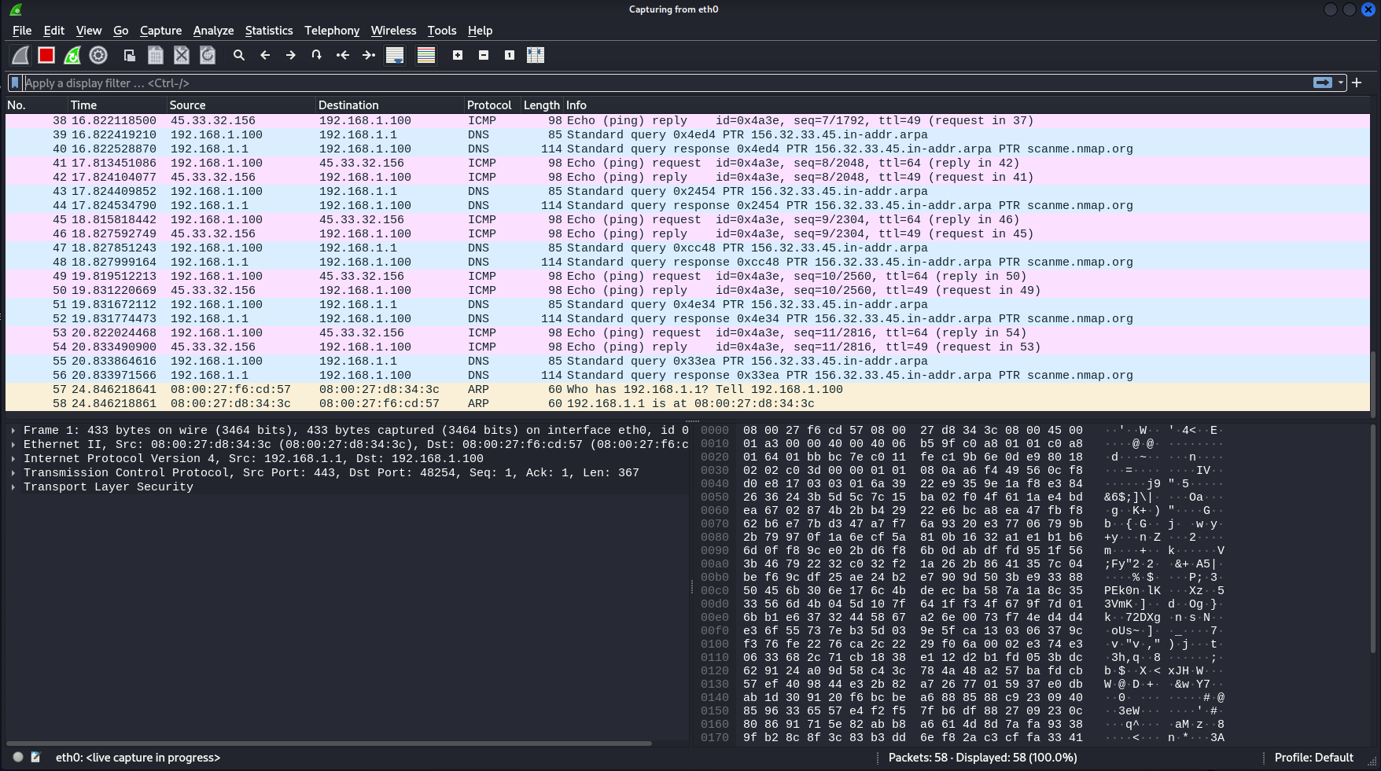

### **Part 5: Questions**

* **~~On pfSense, navigate to the Dashboard, and locate the list of active interfaces~~**
  + **~~Does the interface you created have an IP address?~~**
    - **Yes, I gave it one during setup.**

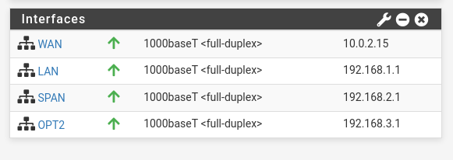

* **~~Disable all network devices on Kali~~ *~~except~~* ~~the span port connection~~**
  + **~~Does the traffic capture still work?~~**
    - **Yes, there was only the loopback link (lo) and that is for self-connections.**

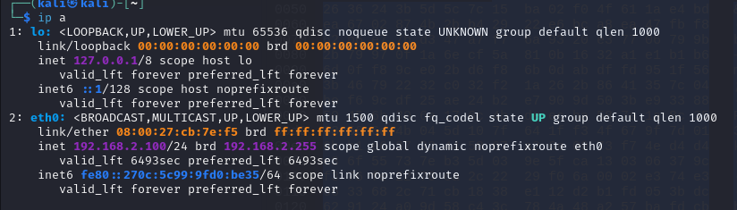

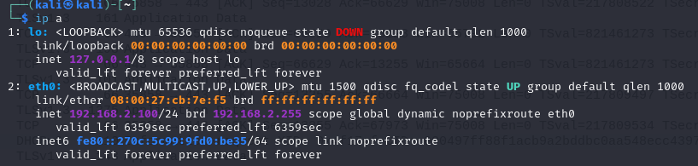

* + **~~Why might you want to disconnect a sniffing machine in this way?~~**
    - **By disabling other connections, a sniffing machine has exclusive access to the network traffic, making it easier to monitor and capture data without being detected by other devices on the network.**
  + **~~On Kali, run~~**

**sudo dhclient -r**

**sudo dhclient**

**ip a**

* + **~~Does Kali have any IP addresses?~~**
  + **No, however it took some time to get rid of the ip addresses**
    - **Disable dhcp leases**
    - **Disable dhcp v6 on kali**
    - **Redo the dhclient - r until you get the “killed old client process”**

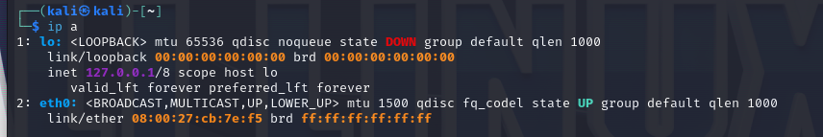

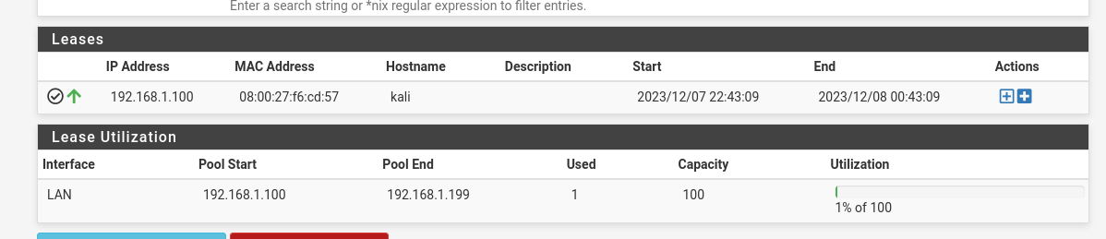

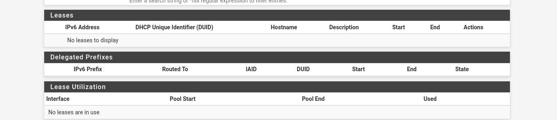

* **~~If neither Kali nor pfSense have an IP address on the span port connecting them, how is traffic being sent from pfSense and reaching Kali?~~**
  + **Because promiscuous mode is enabled, wireshark doesn’t require an actual ip address to sniff the network, when SPAN is bridged.**

### **Part 6: Topology 2/2**

**When the other tasks are complete, review the topology and update, revise, extend, or add details as necessary.**

**Was your initial topology accurate to the finished product?**

**Why or why not?**

**Yes, mostly. I made some QoL changes to make more sense**

